

White Paper

E-Learn Kenya: Making Learning Accessible, Affordable, and Engaging For Everyone

Prepared by Victor Gitonga

August 27, 2025

# Executive Summary

E-Learn Kenya was founded by Victor Gitonga in partnership with James Thuranira, a certified teacher and Kenya National Examinations Council (KNEC) examiner. Together, they envisioned a platform that democratizes access to knowledge for learners across Kenya and beyond. With free courses, structured notes, quizzes, and AI-powered support, E-Learn Kenya provides high-quality education to students from junior school through university. While most content is freely available, advanced learning tools and premium content are offered at a small, transparent fee to sustain the platform. Importantly, all content is developed and reviewed by certified teachers — led by James Thuranira and other qualified educators — to ensure accuracy, relevance, and real classroom value.

As the mobile application launches soon, E-Learn Kenya is positioned to transform learning by bridging educational gaps, empowering communities, and preparing learners for both academic and life challenges. We invite sponsors and partners to join us in scaling this mission.

## 2. Background & Problem Statement

Kenya, like many countries in Africa, is undergoing a rapid digital transformation. However, access to quality education has not kept pace with this growth. Despite government reforms such as the Competency-Based Curriculum (CBC), significant gaps remain in how learners access and interact with educational content.

**Key Challenges**

* **Limited Access to Resources**: Many learners, particularly in rural and marginalized areas, still lack access to reliable, well-structured, and affordable study materials.
* **High Cost of Digital Alternatives**: While e-learning solutions exist, many are fragmented, subscription-based, or priced beyond the reach of average families.
* **Exam Preparation Gaps**: Students preparing for examinations or professional certifications (CPA, ACCA, etc.) often struggle to find localized, affordable digital tools tailored to their syllabus.
* **Underserved Community Education**: Beyond formal schooling, there is little online support for health awareness, entrepreneurship, financial literacy, and vocational training.

**Missed Opportunities**

Even where infrastructure exists — for example, schools with internet access — the potential of digital learning is not fully realized. Teachers could post assignments, quizzes, and study materials online, reducing the cost and time of preparing physical exams and revision papers. However, most schools lack an organized, easy-to-use platform that supports this interaction effectively.

**The Consequence**

These challenges and missed opportunities create a **digital divide**. Learners in urban and well-resourced areas gain access to better content and support, while those in rural and disadvantaged communities remain excluded. This inequality not only hinders individual growth but also slows national progress toward inclusive education and sustainable development.

## 3. Our Solution: E-Learn Kenya

**Overview**  
E-Learn Kenya delivers a web-first learning platform designed to make high-quality, syllabus-aligned learning truly accessible. Our core promise is simple: most learning resources remain free, while a small, transparent fee supports advanced AI-driven services and premium content. The platform combines structured lessons, multiple auto-marked quizzes with step-by-step explanations, and teacher tools so schools and communities can use the system without extra cost.

**Key features**

* **Structured learning for all** — courses and lesson modules for CBC (junior & senior secondary), community lessons (health, entrepreneurship, digital literacy), and higher education / professional exam support (e.g., CPA). Most lessons, open quizzes and core materials are free to access.
* **Multiple quizzes + auto-marking** — unlimited multiple-choice (and multi-answer) quizzes. Answers are auto-marked on submission so learners get instant scores and can repeat practice runs. Auto-marking supports partial credit where applicable.
* **Step-by-step explanations** — every open quiz links to a clear worked solution so learners learn from mistakes immediately (not just see a score). These explanations include references and suggested follow-up lessons.
* **AI integration (GPT-5 powered)** — personalized study help, answer clarifications, guided worked examples and smart revision prompts. We use the paid GPT-5 tier for advanced, contextual tutoring; free users receive a limited set of AI interactions. The small fee paid by some users covers API costs and allows the platform to keep the majority of learning content free.
* **Learner analytics & progress tracking** — each learner can track scores, improvement over time, and topic-level strengths/weaknesses. Teachers can view class performance summaries (planned/available features).
* **Low-connectivity / mobile friendly** — the platform is optimized for low bandwidth. The forthcoming mobile app will include lightweight pages and cached content so learners in low-connectivity areas can study with minimal data.

**Teacher Tools — For Schools**

E-Learn Kenya includes a dedicated set of features designed to support teachers.

* **Quiz & Lesson Creation:** Teachers can create their own lessons and private class quizzes tailored to their students.
* **Assignment via Class Codes:** Quizzes or lessons can be shared with specific classes using unique codes, ensuring only the intended learners participate.
* **Participation Tracking:** Teachers can view which students attempted each quiz, the time of submission, and the score received.
* **Grading & Feedback:** Quizzes are auto-marked, with results displayed instantly. Teachers can review student grades individually or as a class summary.
* **Cost Reduction:** By digitizing assignments and quizzes, schools reduce reliance on printed materials, lowering exam preparation costs.

**How the quizzes + AI experience works (user flow)**

1. Learner selects a module → chooses a quiz (or teacher assigns one).
2. Learner completes the quiz; the system auto-marks responses and shows immediate feedback.
3. For each question the learner can tap **“Show Explanation”** to open a step-by-step worked solution.
4. If the learner wants deeper help, the built-in AI tutor (GPT-5) can provide a tailored walkthrough or suggest next exercises. Free users have limited AI access; paid access gives longer, more interactive AI sessions.

**Screenshots & visuals**

* **Screenshots — Learner quiz page** (shows question, options, submit button, instant score).

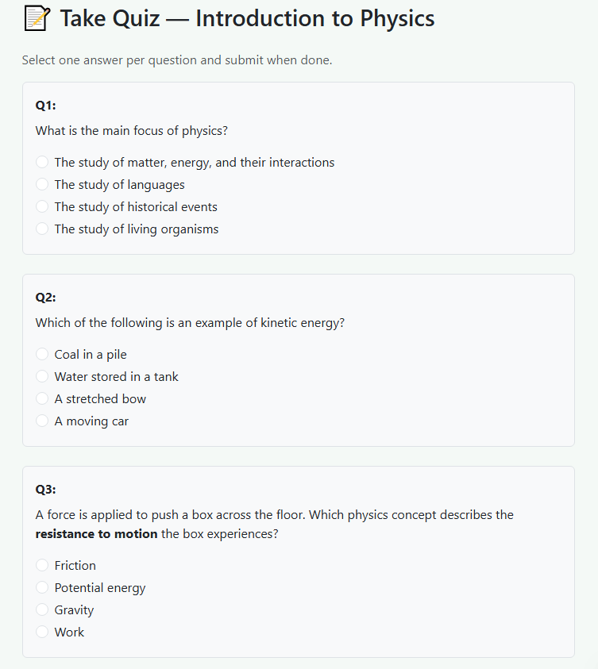

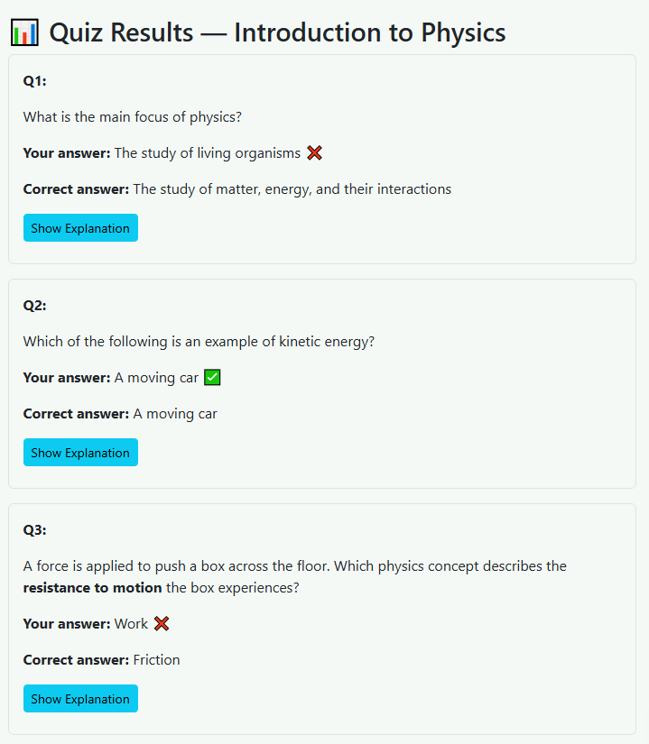

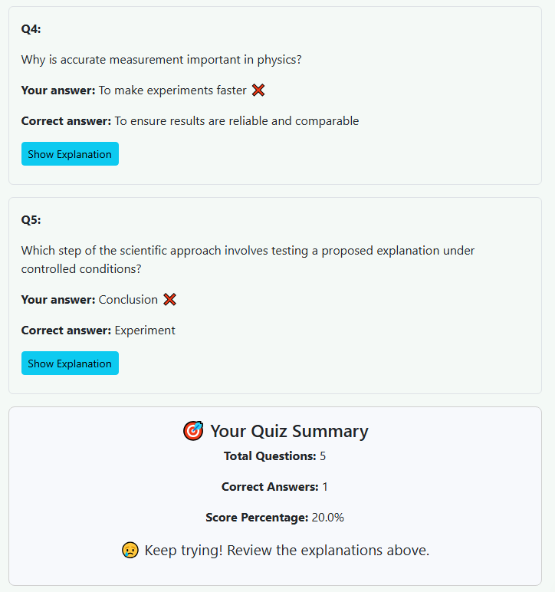

* **Screenshots — Step-by-step explanation page** (worked solution for a sample question).

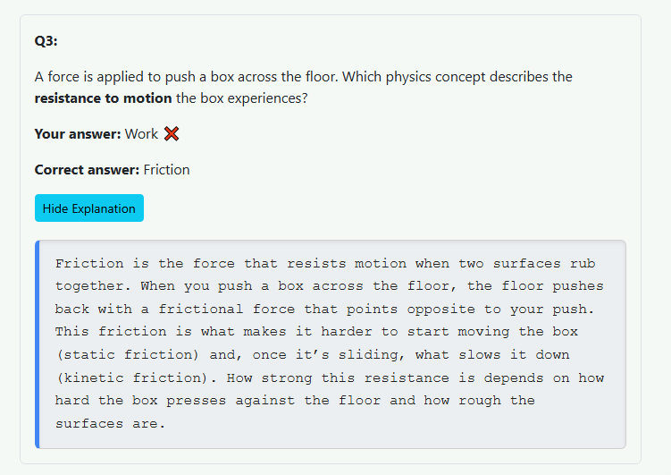

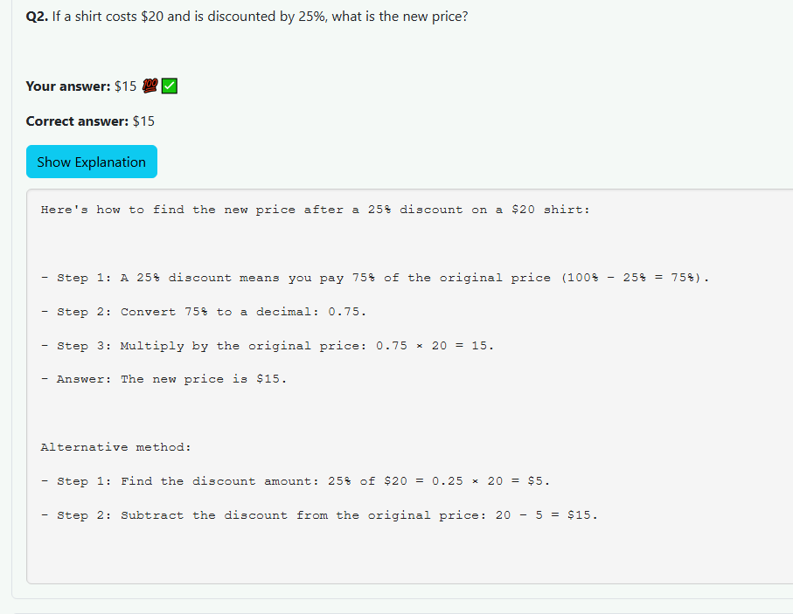

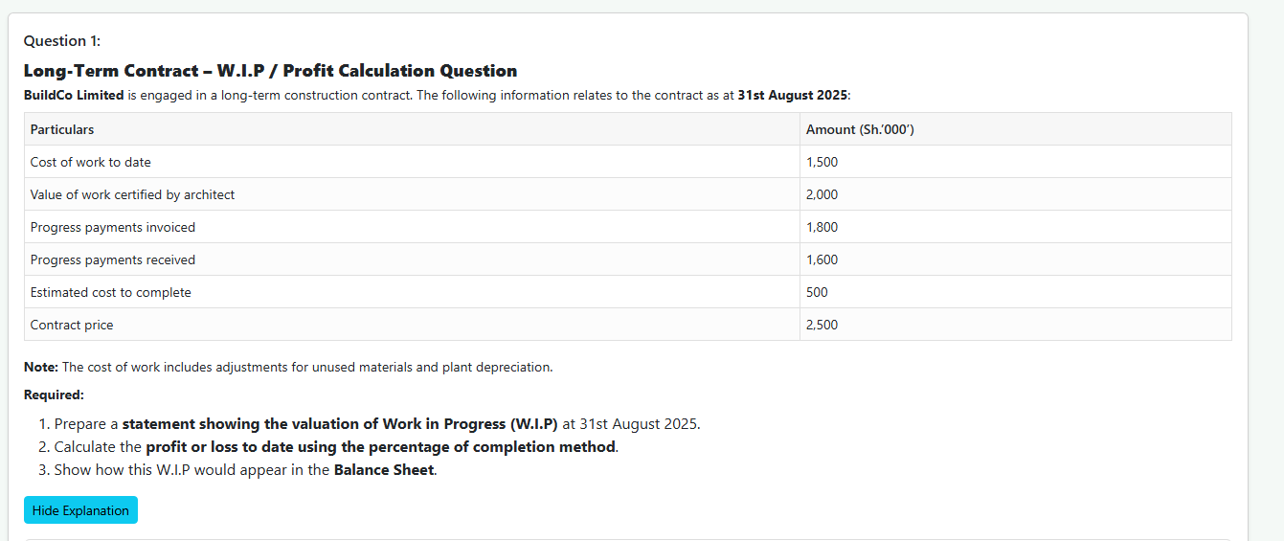

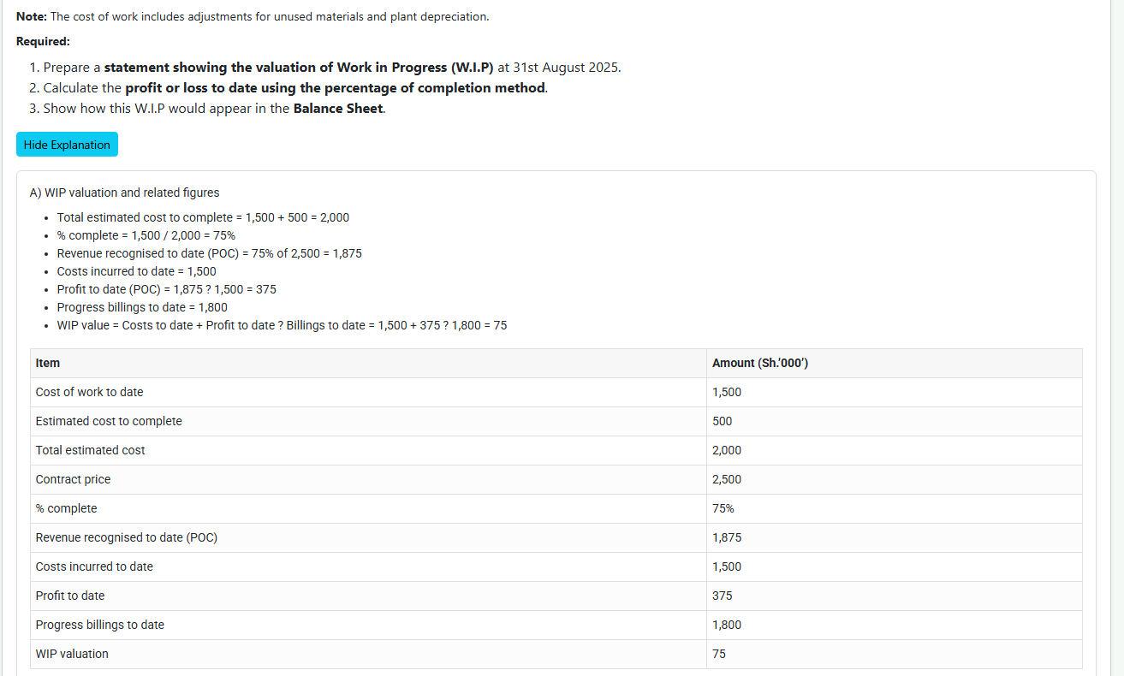

* **Screenshots — AI tutor session** (chat-style walkthrough with GPT-5 responding to a learner’s question).

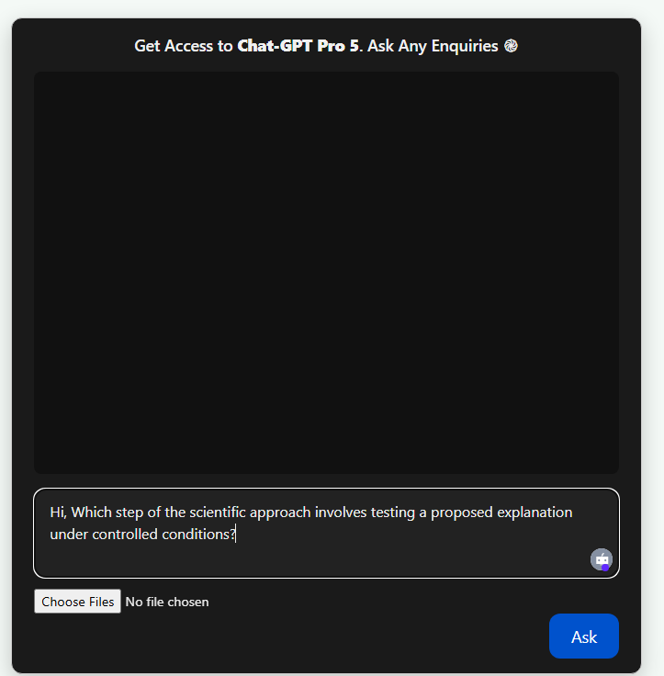

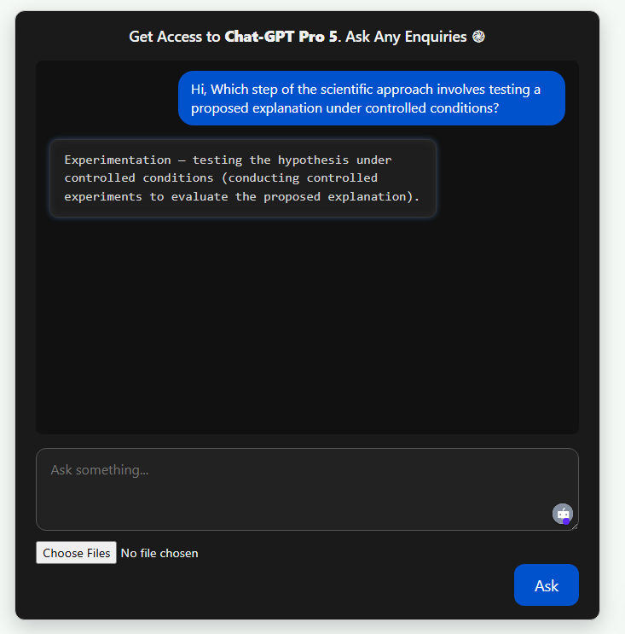

* **Screenshots — Teacher dashboard** (quiz creation flow, class list).

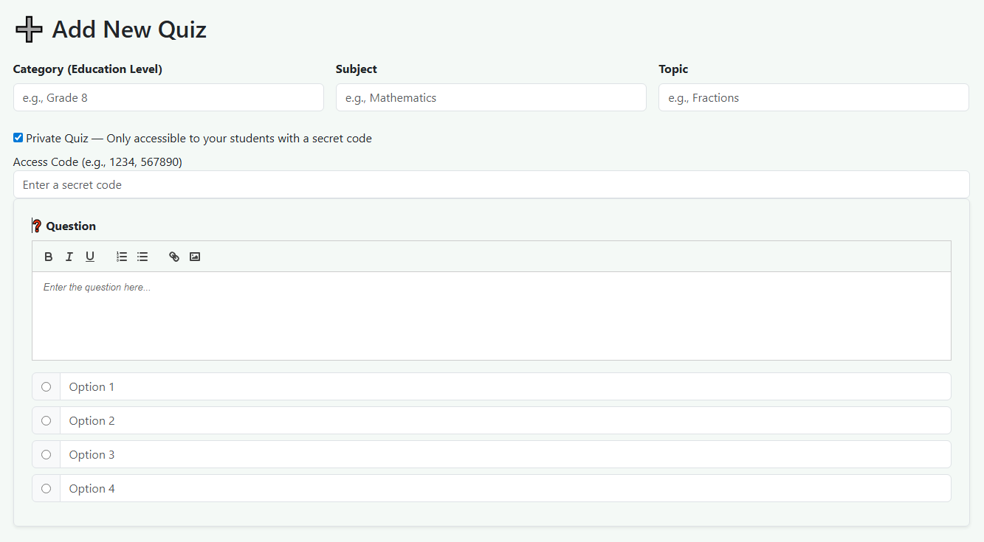

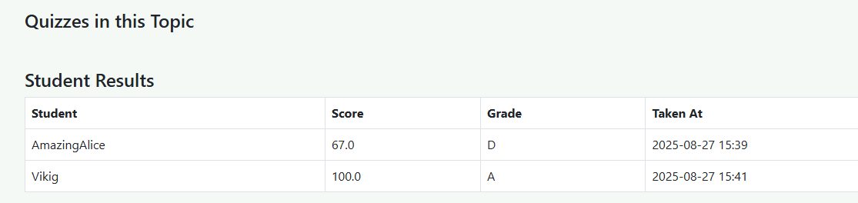

* **Screenshots — Student’s Dashboard Course catalogue / mobile mockup** (how modules appear on small screens).

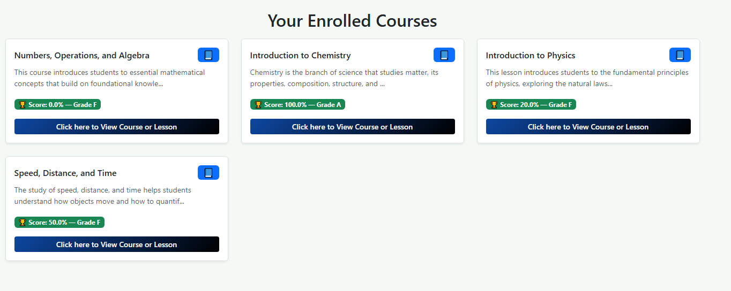

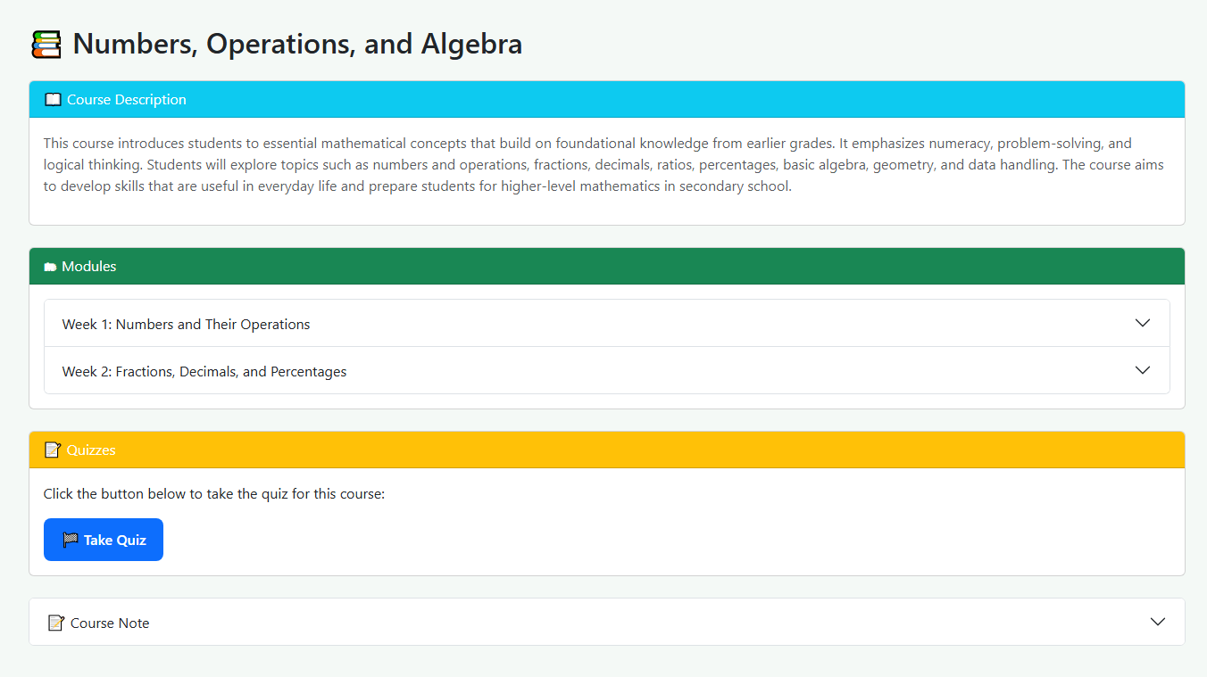

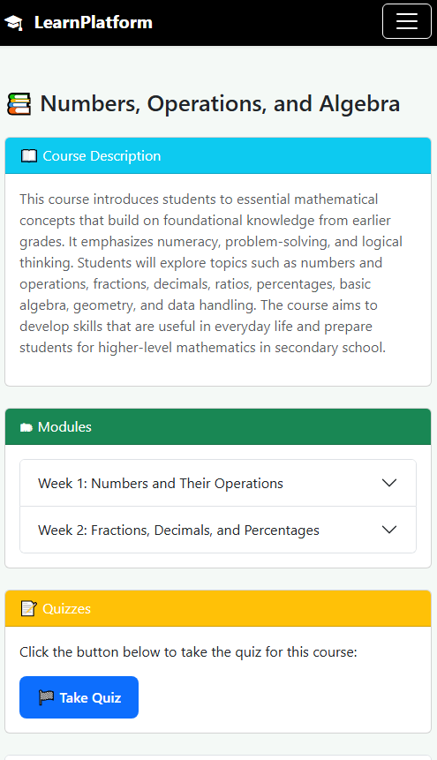

**Data, privacy & responsible AI**

E-Learn Kenya recognizes that responsible use of artificial intelligence and learner data is essential to building trust with students, parents, teachers, and sponsors. Our approach is built on transparency, safety, and accountability.

* **Secure AI Integration**: AI queries are routed to the paid GPT-5 service. Personally identifying information is never required and is anonymized wherever possible before processing.
* **Progress Data & Analytics**: We record learner performance and progress data to provide personalized recommendations and track growth over time. All data is collected with consent and in line with best practices for privacy and data minimization.
* **Clear Transparency**: All premium and AI features are clearly labeled. Learners know which tools are freely available and which require a small fee to cover AI service costs.
* **Responsible Use**: AI responses are monitored for quality and accuracy. Inappropriate or harmful content is filtered to ensure a safe learning environment.
* **Data Ownership**: Learners and schools retain ownership of their data, which is used only to improve the learning experience and not for commercial resale.

**Immediate benefits & school impact**

E-Learn Kenya delivers direct and measurable benefits to schools, teachers, and learners:

* **Reduced Costs for Schools**: Teachers can publish quizzes and assignments online, eliminating much of the time and expense involved in preparing and printing physical exams or revision papers.
* **Accessible in Low-Connectivity Areas**: Even schools with limited internet access can benefit, as teacher tools allow distribution of materials and auto-marking of student practice without heavy bandwidth demands.
* **Teacher Efficiency**: Automated marking and participation tracking reduce administrative workloads, giving teachers more time to focus on teaching and mentoring.
* **Improved Learning Outcomes**: Learners receive instant feedback, step-by-step explanations, and optional AI tutoring — boosting study efficiency, exam readiness, and long-term retention of knowledge.

## 4. Why We Charge a Small Fee

E-Learn Kenya is not profit-driven. While most resources are free, select premium areas attract a minimal fee. This model ensures:

* Platform maintenance and security.
* Hosting and AI service costs.
* Continuous expansion of free courses for all learners.

Transparency is key: all free and premium content is clearly labeled, empowering learners to choose.

## 5. Impact & Benefits

E-Learn Kenya is more than a platform — it is a catalyst for inclusive education and social development. By aligning with the **Sustainable Development Goals (SDGs)**, it directly advances **SDG 4 (Quality Education)** and indirectly supports **SDG 3 (Good Health & Wellbeing)** and **SDG 8 (Decent Work & Economic Growth)**.

### Key Benefits

* **For Students**
  + Equal access to structured, localized digital resources across CBC grades, universities, and professional certifications.
  + Quizzes with instant feedback and explanations that improve learning efficiency and exam readiness.
  + AI-powered tutoring for personalized learning, even in areas with limited teacher availability.
* **For Teachers**
  + Supplementary tools to support classroom teaching, including the ability to create lessons, assign private quizzes, and track student participation and grades.
  + Reduced costs and workload by replacing printed assignments and manually marked exams with digital auto-marking.
* **For Parents & Guardians**
  + Affordable and reliable alternatives to expensive tutoring and revision materials.
  + Greater visibility into their children’s learning progress through structured lessons and consistent practice.
* **For Communities**
  + Free access to courses in health, entrepreneurship, digital literacy, and vocational skills, supporting lifelong learning beyond formal education.
  + A platform that strengthens digital readiness and creates opportunities for work, innovation, and self-reliance.

## 6. Roadmap & Scalability

E-Learn Kenya has already laid a strong foundation with a live platform offering structured notes, quizzes, and learning modules. The journey ahead focuses on growth, accessibility, and regional expansion.

* **Current Stage**: Platform live and accessible, with free notes, auto-marked quizzes, and structured learning modules available online. Already Partnered with 3 schools, and the platform is performing as expected.
* **Next 6–12 Months**:
  + Launch of the mobile application for Android and iOS to improve accessibility.
  + Expanded CBC (junior & senior secondary) coverage.
  + Rollout of community-focused lessons in health, entrepreneurship, and digital literacy.
  + Launch of CPA and other professional curriculum pathways.
* **Scalability**: Medium-term expansion to East Africa and broader African markets. The platform will adapt to diverse curricula and languages, ensuring inclusivity across regions.

## 7. Partnership & Sponsorship Opportunities

To achieve scale and impact, we invite sponsors, organizations, and institutions to collaborate with E-Learn Kenya. Opportunities include:

* **Financial Support**: Sponsorships to scale platform reach, enhance content, and subsidize premium features for disadvantaged learners.
* **Technology Partnerships**: Infrastructure and integration of advanced digital tools to improve platform performance and reach.
* **Content Collaboration**: Joint development of learning modules, community education lessons, and specialized training programs.
* **CSR Opportunities**: Partnerships that align with corporate social responsibility goals in education, digital inclusion, and community development — delivering measurable social impact while strengthening brand visibility.

## 8. Conclusion & Call to Action

E-Learn Kenya is more than a platform — it is a **movement to make knowledge accessible, affordable, and empowering for every learner**. By bridging digital divides and providing high-quality resources at little or no cost, we are unlocking opportunities for students, teachers, parents, and communities across Kenya and beyond.

With the right partnerships and sponsorships, this initiative can scale rapidly, reaching millions of learners and shaping a more inclusive future for education.

**Join us in shaping the future of learning in Kenya and beyond.**

📧 **Contact**: +254798637915  
🌐 **Website**: https://elearnkenya.org/